Monthly Performance Report – February 2025
Kestrel Ridge Wind Farm (75.6 MW)
David Chen · 09 March 2025 · KR-OPS-RPT-2025-02

1. Summary
Kestrel Ridge generated 18.7 GWh in February 2025, 11.8 % below the P50 budget of 21.2 GWh. Availability of 97.1 % met the contract target of 97.0 %. The wind resource was weak: 8.8 m/s against a long-term monthly mean of 9.4 m/s.

2. Production and key figures
KPI | February 2025 | Budget / target | YTD 2025 | YTD budget
Net generation (GWh) | 18.7 | 21.2 | 43.9 | 46.4
Time-based availability | 97.1 % | 97.0 % | 96.9 % | 97.0 %
Capacity factor | 36.8 % | 41.7 % | 41.0 % | –
Mean wind speed at hub height (m/s) | 8.8 | 9.4 | – | –
Source: Kestrel Ridge SCADA, revenue meter at 132 kV point of connection. Budget = P50 (2024 post-construction yield assessment).
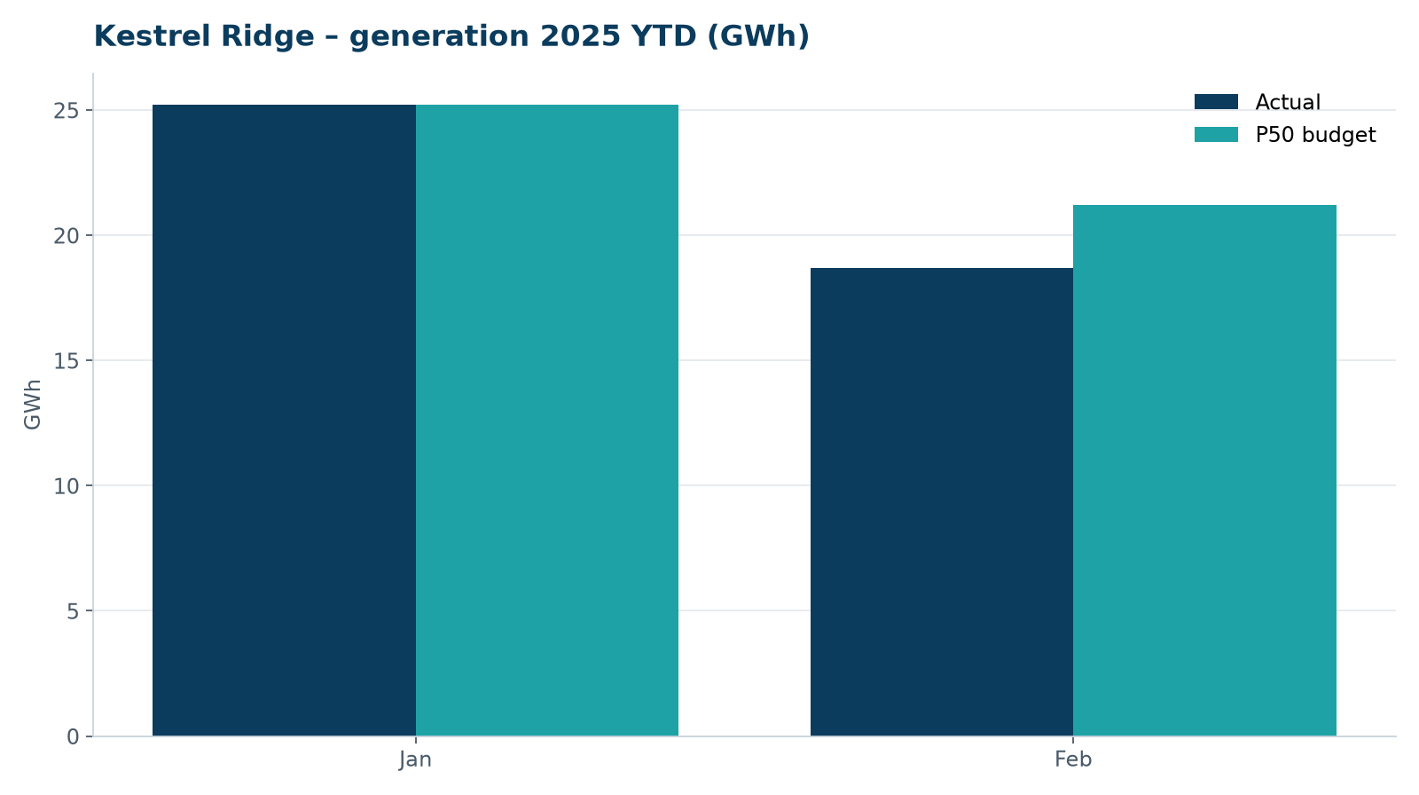
Monthly generation vs. P50 budget, 2025 year to date

3. Availability and downtime
Total turbine downtime attributable to the contractor amounted to 43 turbine-hours for the top events listed below. No grid or force majeure exclusions were claimed this month.
Turbine | Event | Downtime (h)
T-08 | yaw brake pad wear – pads replaced | 15
T-05 | hydraulic oil leak at rotor brake caliper | 13
T-12 | high-voltage transformer gas relay alarm (inspected, no fault found) | 8
T-03 | generator slip ring brush wear alarm | 7
Top downtime events of the month (SCADA event log, reviewed with Highline Wind Services).

4. Maintenance
- 22 corrective work orders closed, 1 still open at month end.
- Site access track inspected; two drainage culverts cleared after heavy rain.

5. Health, safety and environment
Indicator | Month
Hours worked on site (Highline + Weyland) | 2,471
Lost time injuries | 0
First aid cases | 0
Near misses reported | 0
Safety observations | 10
Environmental incidents | 0

No complaints from neighbours were received this month.

6. Outlook
We will review the downtime events above with Highline in the monthly O&M meeting and track the recurring pitch faults.
Prepared by Sara Lindgren (Performance Analyst); reviewed by Ben Okoye (Site Manager) and David Chen (Asset Operations Manager).

